Name: REYES, DENIEL T.

Module 10
Assessment Task 10

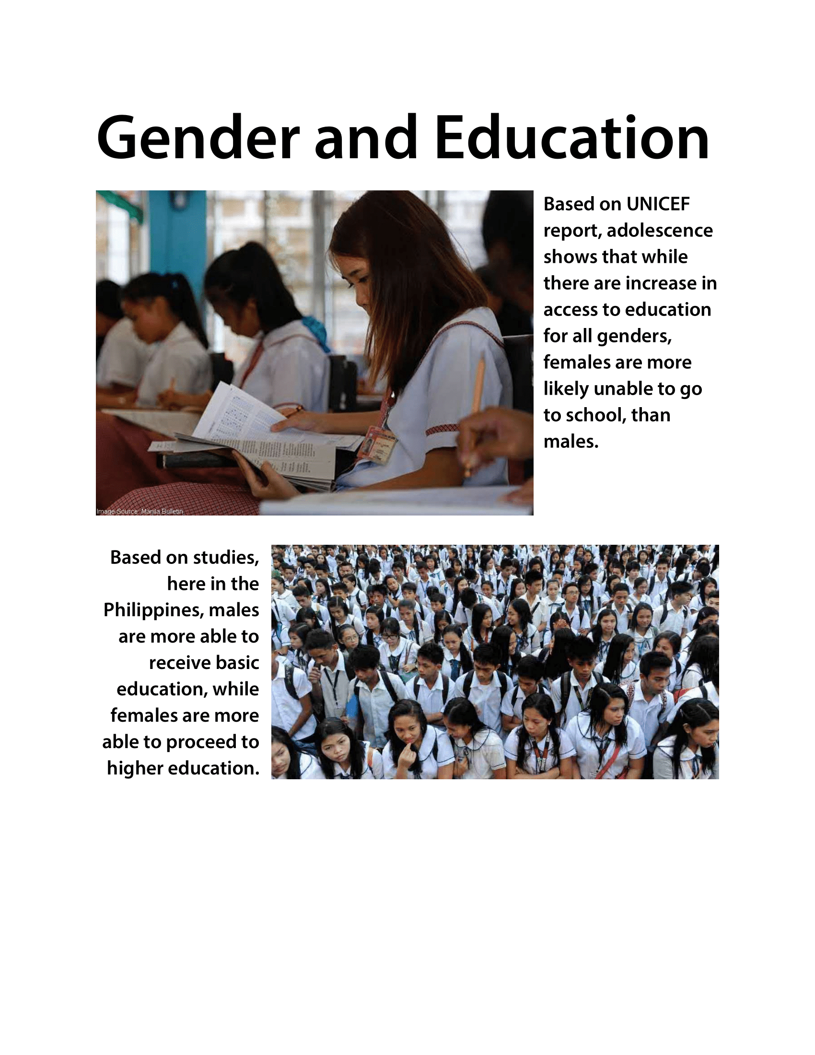
- 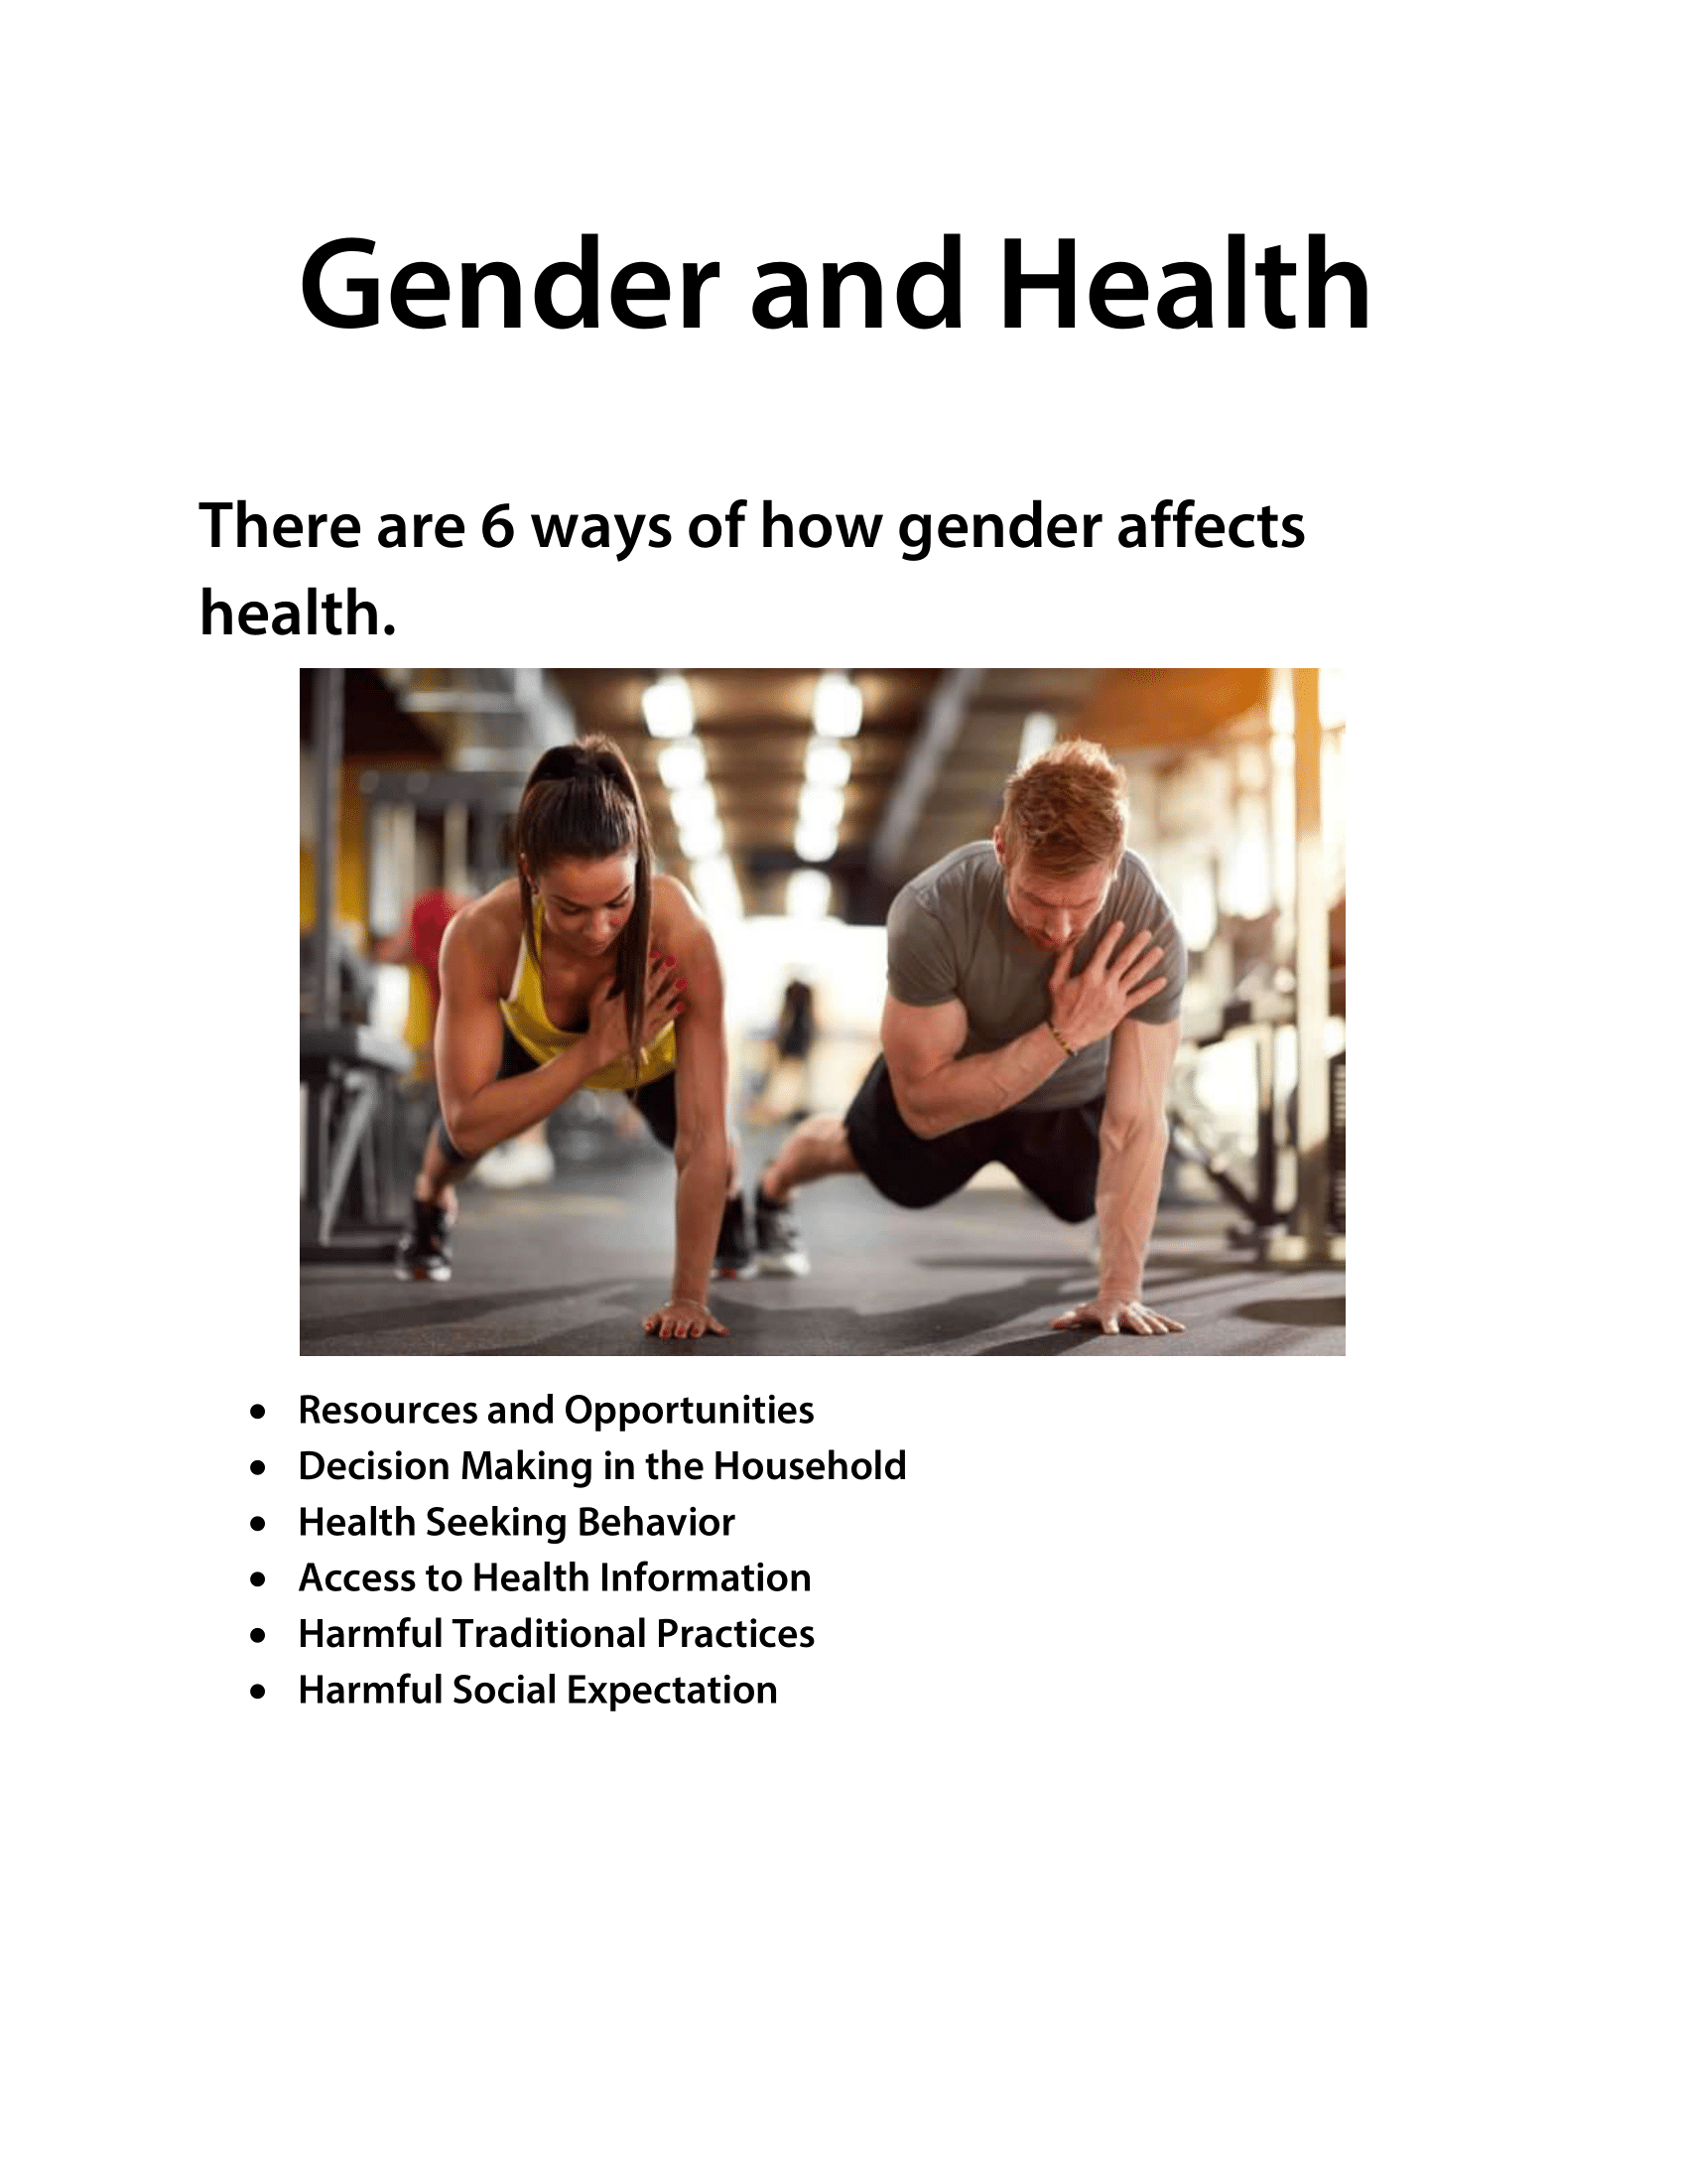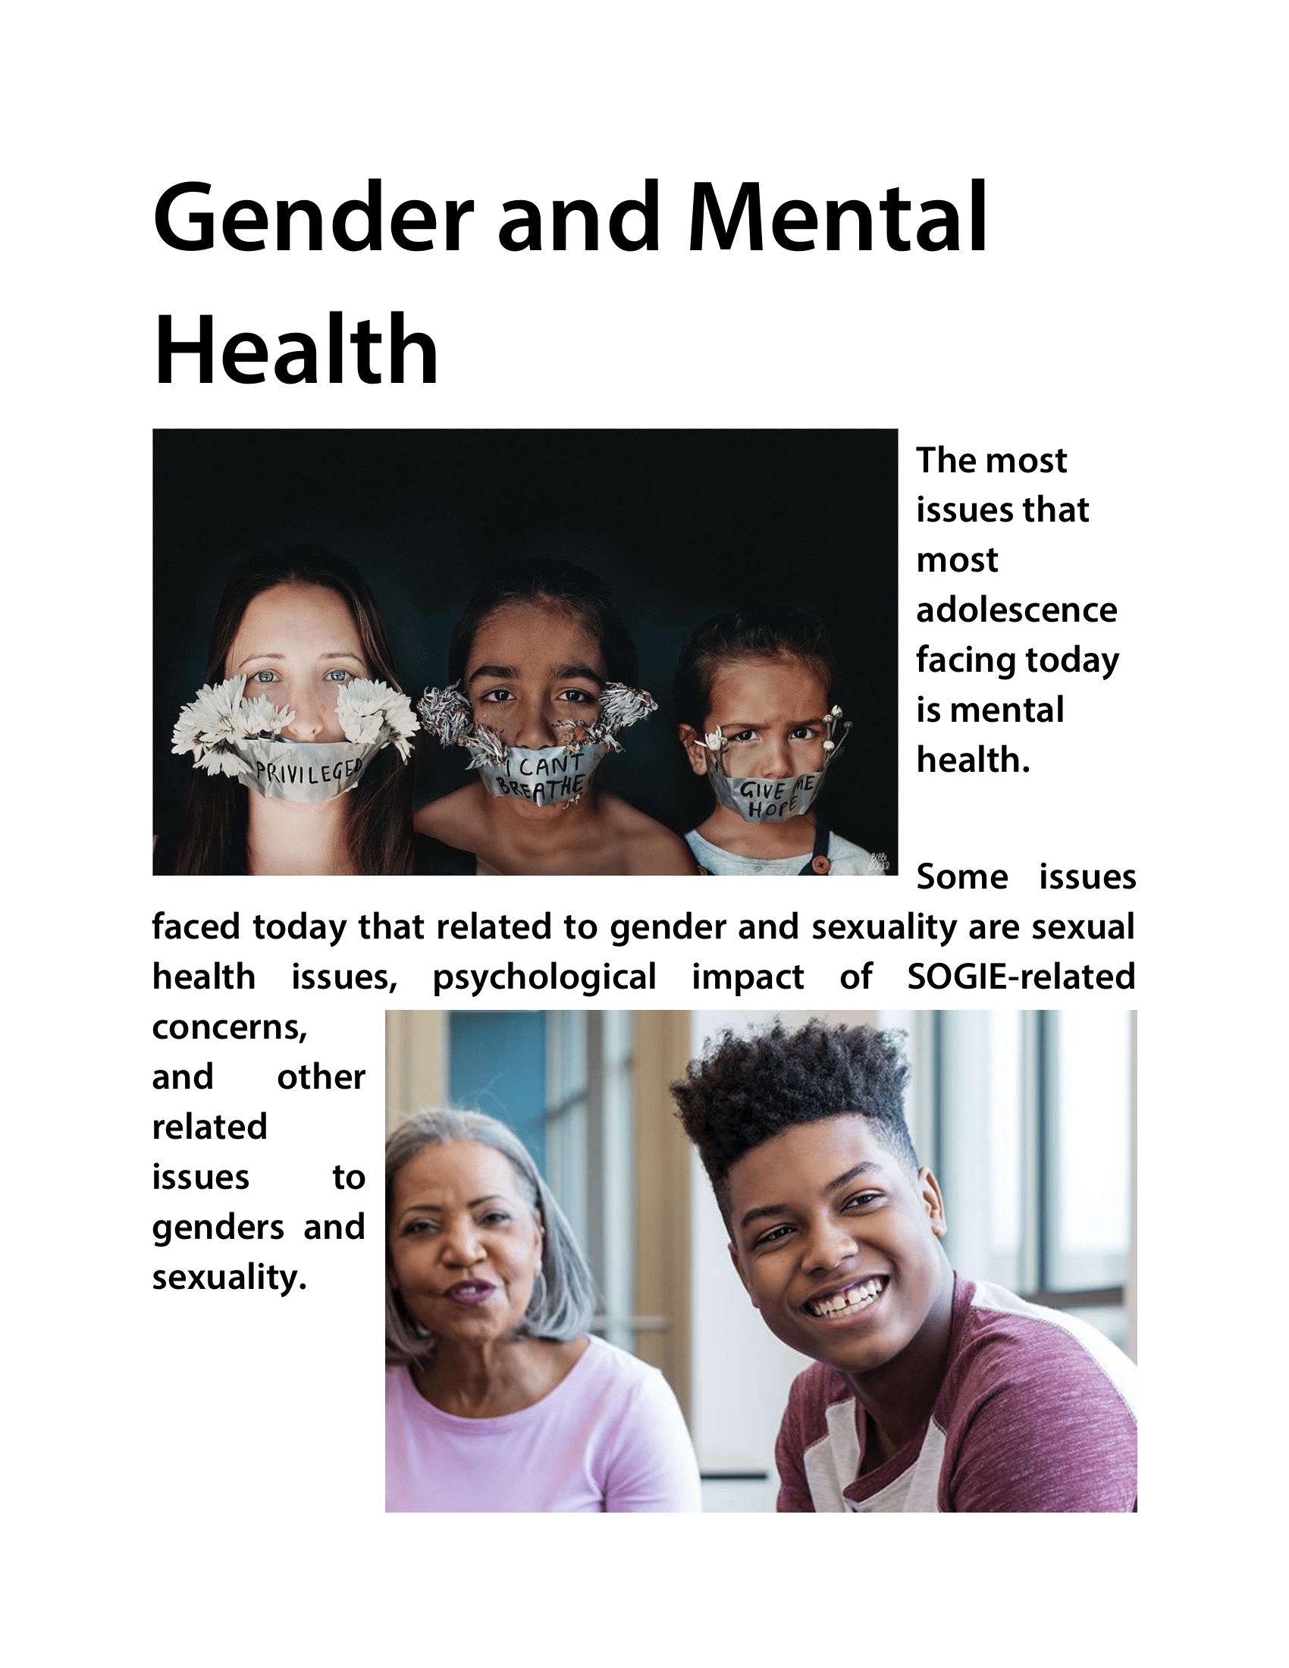
- Write a reflection paper: Did the concepts I learned from previous lessons helped me become more intelligent in making choices related to my gender and sexuality? If yes, how? If no, what else could be done so that I can gain more information to base my healthy decisions from?
The concepts I learned from previous lessons helped me become more intelligent in making choices related to my gender and sexuality. It helped me to have more information regarding to my sexuality and gender, and I made choices that is good for myself.
- Write a reflection paper on topics/links (Supplemental links 1-4 in this module).
Biology can help you avoid certain health problems. However, most health conditions affect both men and women to some degree for a variety of reasons. Many health risks for men can be behavioral. In general, men engage in behaviors that increase the risk of injury and disease. They also tend to adhere to less healthy diets. While, anatomy and hormones are often mentioned when talking to doctors about the risks to a woman's health. Essentially, it means living a healthy lifestyle - men and women need to do the same to take care of themselves.
Gender refers to the social relationships between men and women in the form of roles, skills based on different levels of power. The health care system itself is not gender neutral. In addition to differences in health behaviors associated with exposure to several diseases, gender is also associated with responses to symptoms and signs of disease. Studies show that women are more likely than men to seek care after becoming accustomed to reproductive health counseling. However, other factors, such as women's lack of autonomy to pay for their own health care, may prevent women from accessing health care. Addressing existing gender inequality and its complex determinants to realize everyone's right to health and well-being is a challenge.
Primary education forms the basis of lifelong learning. Most countries have achieved gender equality when they started primary school, but many continue to have inequality that is detrimental to girls. It mostly persists in Africa, Middle East, and South Asia. Barriers that prevent children from attending primary school vary from country to country, but are often associated with poverty, geographical isolation, armed conflict, lack of school infrastructure, and inadequate education.
There are 6 ways on how gender affects health, and at the first look, I thought that I know them, and then I realize that this is the first time that I hear about these ways. 6 ways are Resources and opportunities, Decision making in the household, Health seeking behavior, Access to health information, Harmful traditional practices, and Harmful social expectations. All of the lessons, I gain knowledge about gender and other issues.

